The Center gets a research group in in Health Promotion and Community Care based at Gjøvik Campus.

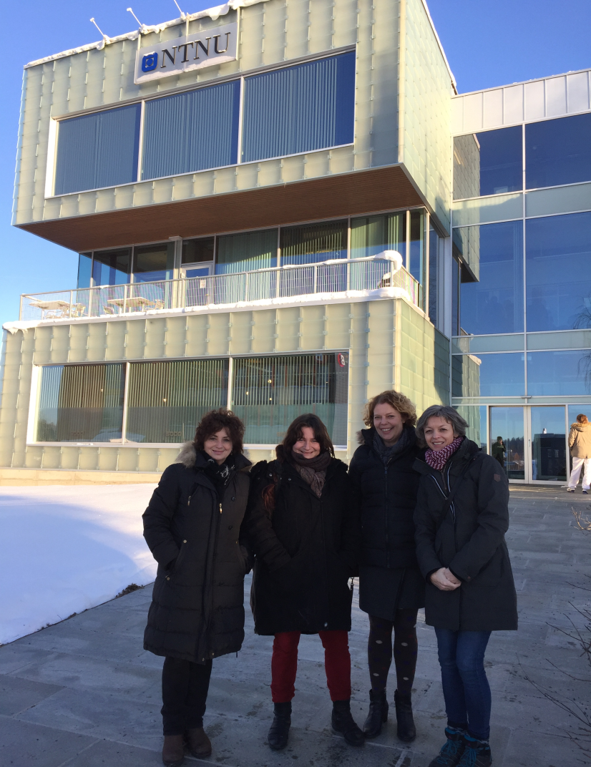
Members in the Research Group of Health Promotion and Community Care in meeting at Gjøvik Campus. Kari Bjerke Batt-Rawden, Ruca Maass, Kirsti S. Anthun and Øyfrid Larsen Moen.

------ Read more about HPCC– lenke ---

The Center has established a Research Group in Health Promotion and Community Care (HPCC) based at the Gjøvik Campus.
The Research Group - Members: Kari Bjerke Batt-Rawden (Leader) (Associate Professor), Ruca Maass (phd scholarship), Kirsti S. Anthun (Associate Professor), Geir Aild Espnes (Professor), Geir Berg (Associate Professor), Øyfrid Larsen Moen (Associate Professor), Arne Orvik, (phd scholarship). The Group represents researchers from NTNU in Gjøvik,Trondheim and Ålesund. Associated members: Professor Olav Garsjø and Associate Professor Torbjørn Andersen.Gunn Haraldseid (Assistant Professor) from the University of Stord is a collaborating partner.

The Research Group HPCC
The Research Group in Health Promotion and Community Care at Gjøvik Campus are members of NTNUs Center for Health Promotion Research which is a center with national and international reputation and prestige. For NTNU Gjøvik The Research Group HeLo will represent novel and evidence based research on health promotion and community care in a local context.

Main objective: The Research Group will build national and international research competence, including promoting internal collaboration at NTNU, contributing to develop and execute high quality research. The Research Group will act as an attractive partner towards exciting research milieus both nationally and internationally. Additionally, its role is to establish research milieus that increase the volume of NTNUs research productions and publications, particularly through an increase in external financial support and activities.
The Research Group also has an aim to strengthen the master program (MHPCC) at NTNU.

Performance targets
The research group has a vision to become a leading national and international Research Group on Health Promotion and Community Care where dissemination of knowledge and implementation of teaching and practice is central.

Targets to achieve
To have significant and positive impact on public health strategies, health education, employment and society by using a holistic and salutogenic approach to health promotion.

Application for phd scholarship
The research group is now applying for a phd scholarship which will be applied to the following overarching question: How can good local communities and housing environments promote health by strengthening participation and inclusion?
Three objectives:
(1) How schools, workplaces and leisure activities (voluntary organizations) can contribute to good health in local communities.
(2) How singing, music and culture can be health promoting factors (salutogenic) (the collaboration with HUNT, NTNU plays a significant role)
(3) How use of natural environment can be a salutogenic factor.

