**The CoE Centre for Autonomous Marine Operations and Systems are proud to announce the visit of Professor Andrew R. Teel, University of California at Santa Barbara in fall 2015.**

**As part of the NTNU course MR8500: Advanced Topics in Marine Control Systems** (study level: PhD; credits: 10.5), he **will give a 2-week intensive graduate course on the topic:**

# Stochastic Hybrid Dynamical Systems

The course will be held the weeks of September 7-18, 2015, and interested graduate students and PhD candidates should include MR8500 in their course plans for Fall 2015.

Course summary

The course serves as an introduction to stochastic hybrid dynamical systems. As background, the first week will feature material on non-stochastic hybrid systems from the book "Hybrid Dynamical Systems", by R. Goebel, R.G. Sanfelice, and A.R. Teel, Princeton University Press, 2012. The second week will delve into stochastic hybrid dynamical systems, guided by papers on this topic published by Professor Teel.

The course covers modeling and stability theory for (stochastic) hybrid dynamical systems. The stability analysis tools are applied to prove closed-loop stability for control systems that employ hybrid feedback algorithms. The goal is to equip the student with state-of-the-art analysis and synthesis techniques for hybrid feedback systems. In order to follow the material in the course, it is helpful to have taken courses on linear systems (from a state-space point of view) and nonlinear systems (from a book like Hassan Khalil's “Nonlinear Systems”), and to be comfortable with the mathematics used in those courses. In addition, some familiarity with random processes would be helpful.

The first week starts with examples of hybrid systems and then rigorously defines the solution concept, with a focus on hybrid time domains. Next, asymptotic stability of closed sets is studied. Lyapunov-based methods are emphasized. Subsequently, the course addresses basic regularity conditions on the data of a hybrid system that guarantee the hybrid system is “well posed”, in the sense that small perturbations to the data do not change the nature of the possible solutions. Set-valued analysis techniques are introduced to characterize this well-posedness property. Next, asymptotic stability is revisited for well-posed hybrid systems and several equivalent characterizations, including converse Lyapunov theorems, are given. Finally, stability analysis tools based on the invariance principle for hybrid systems are developed.

The second week addresses similar issues for stochastic hybrid systems, that is, systems where jumps can be triggered randomly in time, the values of the jumps may be determined by a random variable, and a Brownian motion may drive the flows. Examples of such systems will be presented, and the solution concept will be developed. Subsequently, much of the focus will be on stability theory for these systems.

Literature list:

**Non-stochastic hybrid systems:**

1) *Hybrid Dynamical Systems*, R. Goebel, R.G. Sanfelice, and A.R. Teel, Princeton University Press, 2012.

2) “Hybrid Dynamical Systems”, R. Goebel, R.G. Sanfelice, and A.R. Teel, *IEEE Control Systems Magazine*, vol. 29, no. 2, pp. 28-93.

**Stochastic hybrid systems:**

1) “Stability analysis for stochastic hybrid systems: a survey”, A.R. Teel, A. Subbaraman, and A. Sferlazza, *Automatica*, vol. 50, no. 10, 2014, pp. 2435-2456.

2) “Lyapunov conditions certifying stability and recurrence for a class of stochastic hybrid systems”, A.R. Teel, Annual Reviews in Control, vol. 37, no. 1, 2013, pp. 1-24.

3) “On sequential compactness of solutions for a class of stochastic hybrid systems”, A.R. Teel, *Proceedings of the American Control Conference*, 2014, pp. 4512-4517.

4) “A Krasovskii-LaSalle function based recurrence principle for a class of stochastic hybrid systems”, A. Subbaraman and A.R. Teel, *Proc. of the IEEE Conf. on Decision and Control*, 2014, pp. 2310-2315.

5) “Stochastic hybrid inclusions with diffusive flows”, A.R. Teel, *Proceedings of the IEEE Conference on Decision and Control*, pp. 3071-3076, 2014.

6) Book by Rockafellar and Wets “Variational Analysis”.   The book is available online for free at Professor Rockafellar’s website: <http://www.math.washington.edu/~rtr/papers/rtr169-VarAnalysis-RockWets.pdf>

About the lecturer

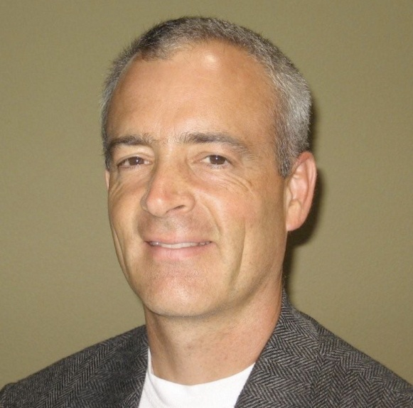Andrew R. Teel received his A.B. degree in Engineering Sciences from Dartmouth College in Hanover, New Hampshire, in 1987, and his M.S. and Ph.D. degrees in Electrical Engineering from the University of California, Berkeley, in 1989 and 1992, respectively. After receiving his Ph.D., he was a postdoctoral fellow at the Ecole des Mines de Paris in Fontainebleau, France. In 1992 he joined the faculty of the Electrical Engineering Department at the University of Minnesota, where he was an assistant professor until 1997. Subsequently, he joined the faculty of the Electrical and Computer Engineering Department at the University of California, Santa Barbara, where he is currently a professor. His research interests are in nonlinear and hybrid dynamical systems, with a focus on stability analysis and control design. He has received NSF Research Initiation and CAREER Awards, the 1998 IEEE Leon K. Kirchmayer Prize Paper Award, the 1998 George S. Axelby Outstanding Paper Award, and was the recipient of the first SIAM Control and Systems Theory Prize in 1998. He was the recipient of the 1999 Donald P. Eckman Award and the 2001 O. Hugo Schuck Best Paper Award, both given by the American Automatic Control Council, and also received the 2010 IEE Control Systems Magazine Outstanding Paper Award. He is an area editor for Automatica, and a Fellow of the IEEE and of IFAC.