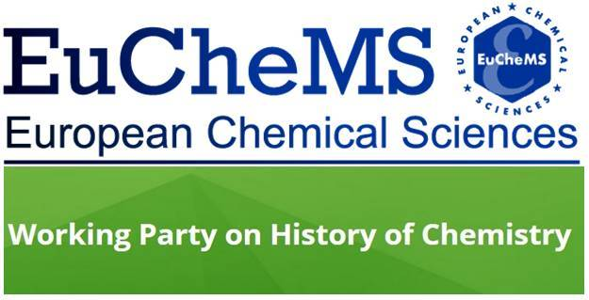 | 11th International Conference  on the History of Chemistry  Trondheim, Norway  29 August – 2 September, 2017

PANEL SUBMISSION FORM
[Please note that, besides the session abstract, panel submissions must come with separate abstracts of the individual papers.]
Organiser(s): (please indicate name, affiliation, and email)

Panel title:

Abstract of the session: (max. 150 words)

Number of papers / requested time slot:

Panel participants  1.  2.  3. | Institutional affiliation | Title of presentation | Participant’s email
Organiser(s) short bio (max 25 words each):

Please note that individual abstracts and/or panel proposals with associated abstracts must reach the Programme Committe at 11.ichc.trondheim@gmail.com
by 31 January, 2017.

11th International Conference
on the History of Chemistry
Trondheim, Norway
29 August – 2 September, 2017

PAPERS SUBMISSION FORM*
Title [size 14, bold, centered]
Author(s) name(s) [size 12, centered]
Institution(s) [size 11, italics, centered]
E-mails [size 10, italics, centered, separated by ;]
Abstract (max. 200 words)
The abstract text should be in Arial, size 11, with justified alignment. The abstract should not contain abbreviations, acronyms, citations, footnotes or references.

Keywords: [size 11, justified]

Part of Panel? no (= individual paper)
yes = title of panel:
panel organiser:

*) At the discretion of the Programme Committee individual papers will be grouped in thematic sessions
or can be assigned to an appropriate panel, provided the respective panel organiser agrees.

Individual abstracts and/or panel proposals with associated abstracts must reach the Programme Committe at 11.ichc.trondheim@gmail.com by 31 January, 2017.

