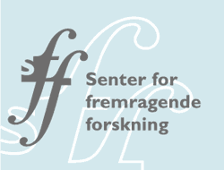
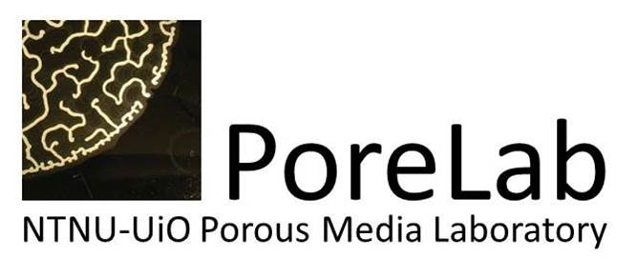
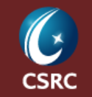

WORKSHOP PROGRAM
Visit from CSRC to NTNU

Tuesday June 19th 2018
Elektro Building, Auditorium EL-3

Chair Professor Asle Sudbø (QuSpin)

09.00-09.30 Professor Hai-Qing Lin (CSRC)

09.30-10.00 Professor Arne Brataas (Center Director QuSpin)

10.00-10.30 Professor Alex Hansen (Center Director PoreLab)

11.00-12.00 Lunch Break

Chair Professor Alex Hansen (Porelab)

12.30-13.00 Professor Rubem Mondaini (CSRC)

13.00-13.30 PostDoc Akashdeep Kamra (QuSpin)

13.30-14.00 Professor Tie-Fu Li (CSRC)

14.00-14.30 Professor Jacob Linder (QuSpin)

14.30-15.00 Coffee Break

Chair Professor Asle Sudbø (QuSpin)

15.00-15.30 Professor Hai-Qing Lin (CSRC)

15.30-16.00 Professor Dennis Meier (QuSpin)

16.00-16.30 Professor Li-Shi Luo (CSRC)

16.30-17.00 PhD Jonas Kjellstadli (PoreLab)

