Title, first line

Title, second line

A.B. Author¹, A.N. Other¹, and Y.E.T. Another²
¹Company name, Country, e-mail
²Company name, Country, e-mail

Keywords: first, second, third, fourth, fifth, sixth

Abstract – A short self-contained summary (preferably about 200 words) goes here. The font used for the abstract is Book Antiqua 9 point.

1. INTRODUCTION
These guidelines have been drawn up to assist authors in the preparation and submission of their papers for the Silicon for the chemical and solar industry XVI proceedings. An A4 page size (210 mm x 297 mm) with a single-column layout is to be used. Use a blank line to separate paragraphs, with no indentation. Full justification is used for all main body text. The font used for the main text is Book Antiqua 11 point. Major headings use Arial bold 11 point.

Authors are responsible for ensuring that their paper is clear and complete, that details are correct, and that there are no spelling or typographical errors. Papers shall be written in standard English.

2. MAJOR SECTION
The length of the paper is less important than the completeness and clarity of the content. Typically, papers will be about 8-12 pages long.

All papers will be refereed in order to ensure that the publication is of a high quality. Referees will be asked to comment on the content, clarity, and relevance of the paper to the intended audience. The organising committee reserves the right to make minor editing changes. If substantial changes to the work are necessary, the paper will be returned to the primary author in order to make the changes.

2.1 Sub-headings
Additional lower-level headings should be bold faced, and placed at the left margin, directly above the paragraphs to which they refer. Capitalize only the first letter of the first word. If a sub-sub-heading is required, bold italics are to be used.

2.2 Tables, figures, and equations
Tables and figures should appear close to where they are mentioned in the text, and should not be all gathered together at the end of the document. Tables should be numbered using Roman numerals, with the caption appearing just above the table, as shown in Table I below. Please do not use automatic cross-referencing for table and figure numbers. The appearance of tables should be kept simple, using as few separating lines as possible. Please avoid colour or shading. Tables and figures must be kept within the margins.

Table I: Caption for Table I

Figures should be numbered using ordinary numerals, and the caption should appear just below the figure, as shown in Figure 1 below.
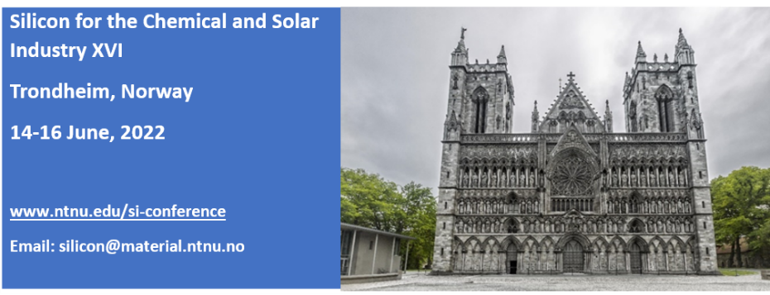
Figure 1: Caption for Figure 1

Graphs with multiple lines should use different styles and line thicknesses to tell them apart. Please avoid extraneous borders. Labels on figures should be clearly legible (typically about 10 points in size).

Equations should be centred, and numbered at the right edge of the paragraph. Please ensure that all terms are adequately defined.

[1]

2.3 Symbols, units, and abbreviations
SI (metric) units should be used. Ensure that symbols are defined. Use standard symbols, units of measurement, and abbreviations. Spell a long term or name out in full the first time it appears and place its abbreviation in parentheses immediately after it. Use the abbreviation in subsequent references. A full stop after an abbreviation is used only when the last letter of the abbreviation is not the last letter of the word. In writing numbers, the full stop is used as the decimal indicator. Numbers of four or more digits are separated into groups of three to the left and right of the decimal place, with a space between the groups.

2.4 References
The Harvard convention for referencing (also called author-date or parenthetical citation) should be used. This system is well documented (Anglia Ruskin University, 2017). A list of references, in alphabetical order, should be provided in the final section of the paper. Examples show the referencing of journal articles (Gerson et al., 1999; Jones, Reynolds, and Alport, 2002), conference proceedings (Norgate, Jahanshahi, and Rankin, 2004), and books with a single author (Von Bogdandy, 1964) or two authors (Kunii and Levenspiel, 1977). Note that the list of references is only left justified and that the titles of only published books and journals are set in italic type. List publication titles in full, and provide the names of all the authors for each reference; retain the abbreviation et al. for the text of the paper. Please include links (URLs) in the references if publications are available online.

3. CONCLUSIONS
Text goes here. Use a blank line to separate paragraphs, with no indentation. Full justification is used for all main body text.

4. ACKNOWLEDGEMENTS
This paper is published by permission of Company Name. The contributions of our colleagues are gratefully acknowledged. (If nothing requires acknowledgement, then leave this section out.)

5. REFERENCES
Anglia Ruskin University. 2017. Harvard System of Referencing.
https://libweb.anglia.ac.uk/referencing/harvard.htm
Gerson A.R., Lange A.G., Prince K.E., and Smart R.St.C. 1999. The mechanism of copper activation of sphalerite. Applied Surface Science, Vol.137, pp.207-223.
Jones R.T., Reynolds Q.G., and Alport M.J. 2002. DC arc photography and modelling. Minerals Engineering, Vol.15, Issue 11S1, pp.985-991.
http://www.mintek.co.za/Pyromet/Files/ArcPhotoModel.pdf
Kunii, D. and Levenspiel, O. 1977. Fluidization Engineering. Huntington, NY: Robert E. Krieger Publishing Company.
Norgate, T.E., Jahanshahi, S., and Rankin, W.J. 2004. Alternative routes to stainless steel – A life cycle approach, Infacon X, Tenth International Ferroalloys Congress, Cape Town, South Africa, 1–4 February 2004, pp.693–704.
http://www.pyrometallurgy.co.za/InfaconX/010.pdf
Von Bogdandy, L. 1964. Die physikalische Chemie der Eisen- und Stahlerzeugung. Verlag Stahleisen, Düsseldorf.

Firstname Surname
Job title, Company name
A brief (about five sentences) biography of the presenting author goes here. This should include a summary of educational qualifications and working history. Mention can also be made of relevant interests. The session chairperson will refer to this biography when introducing the speaker.

