**DCADES LECTURE # 4**

**SOLVENT EFFECTS ON ALCOHOL DEHYDROGENASE: INSIGHTS FROM MOLECULAR DYNAMICS SIMULATIONS**

Jan Philipp Bittner1*; Ningning Zhang2; Pablo Domínguez de María3; Irina Smirnova1; Selin Kara2,4 and Sven Jakobtorweihen1,5

*1 Institute of Thermal Separation Processes, Hamburg University of Technology, Hamburg, Germany 2 Institute of Technical Chemistry, Leibniz University Hannover, Hannover, Germany  
3 Sustainable Momentum, SL., Las Palmas de Gran Canaria, Canary Islands, Spain  
4 Department of Biological and Chemical Engineering, Aarhus University, Aarhus, Denmark  
5 Institute for Chemical Reaction Engineering, Hamburg University of Technology, Hamburg, Germany*

*\* Corresponding author: jan.bittner@tuhh.de*

Understanding the behavior of alcohol dehydrogenase (ADH) in non-conventional reaction media is crucial for optimizing its catalysis in these solutions. The choice of the solvent plays a pivotal role in enhancing biotransformation efficiency while mitigating issues such as limited reactant solubility and water-induced side effects. Deep eutectic solvents (DESs) are a novel solvent class for biocatalysis that offer a high degree of tunability and have already been applied to various biocatalytic systems.1 This study explores the impact of various solvents, including DESs, on horse liver alcohol dehydrogenase (HLADH) using molecular dynamics (MD) simulations.2 The simulations revealed that glycerol has a high affinity for the HLADH surface, which enhances its stability in ChCl-Gly (1:2)-water mixtures. This effect is further improved by adjusting the glycerol molar ratio.2a Spatial distribution functions highlight the solvent’s impact on enzyme flexibility and structural changes (see **Fig. 1**). Based on these results, we proposed new glycerol-containing DESs with a beneficial effect on HLADH. With the help of MD simulations, we could explain the experimentally observed effects of DES-water mixtures on enzyme activity and stability on an atomistic scale.2

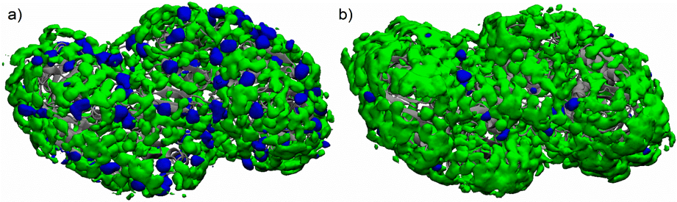

**Figure 1:** Spatial distribution function of glycerol (green) and choline ions (blue) in the proximity of HLADH (gray) in the MD simulations of (a) ChCl-Gly (1:2) and (b) ChCl-Gly (1:9) in mixtures with 20 vol.% water.

This study further focused on the structural changes of HLADH’s active center in diverse reaction environments. The free energy profiles of the substrate molecule (cyclohexanone) along the substrate-binding tunnel to HLADH's active center were quantified using MD simulations. Understanding enzyme behavior at an atomistic level can guide solvent selection for ADH-catalyzed reactions. Thereby, MD simulations provide detailed insights into enzyme- solvent interactions and substrate binding, which can aid in solvent engineering to maintain enzymatic activity under non-conventional reaction conditions.3

[1] a) M. Pätzold, S. Siebenhaller, S. Kara, A. Liese, C. Syldatk, D. Holtmann, *Trends Biotechnol.* **2019**, *37*, 943– 959. b) N. Zhang, P. Domínguez de María, S. Kara, *Catalysts* **2024**, *14*, 84.  
[2] a) J. P. Bittner, N. Zhang, L. Huang, P. Domínguez de María, S. Jakobtorweihen, S. Kara, *Green Chem*. **2022**, *24*, 1120–1131. b) L. Huang, J. P. Bittner, P. Domínguez de María, S. Jakobtorweihen, S. Kara, *ChemBioChem* **2020**, *21*, 811-817.

[3] J. P. Bittner, I. Smirnova, S. Jakobtorweihen, *Molecules* **2024**, *29*, 703.