Precision Dearomatisation With Arene – π- Tribromide Complex and Visible Light Catalysis
Prof. Debayan Sarkar

IIT Indore, Simrol, Madhya Pradesh-40052, India
E-mail: sarkard@iiti.ac.in

Abstract:
Dearomatization reactions have always attracted enough attention as they cater interesting chemical transformations in organic synthesis that facilitate the generation of three-dimensional structures from two-dimensional precursors and thus put forward the best access towards achieving Molecular Complexity. Aromaticity imparts extraordinary stability to the structures due to delocalization of pi electrons. In this regard many synthetic protocols of dearomatization are available. However,a general platform for the oxidative aromatization of common feedstocks is few. Our group has reported the first recognition Tribromide complexes in a number of Dearomative Transformations. The objective has been to understand an unknown Arene π- Tribromide complex Intermediate which would be a major breakthrough towards this direction.
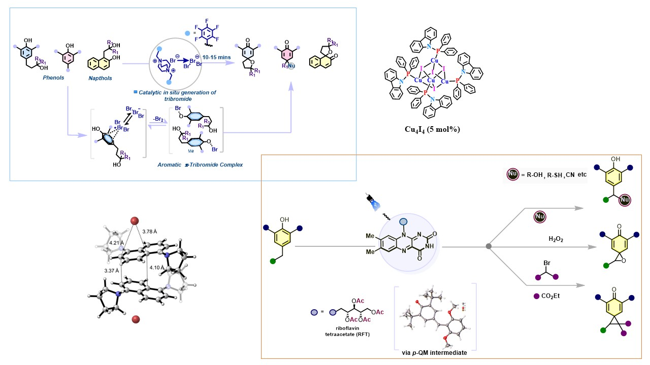
Concurrently, we aim to develop a catalytic, visible-light-driven strategy for transforming abundant and inexpensive planar Arenols and other aromatic core into valuable, complex three-dimensional chiral scaffolds via dearomatization. Its significance lies in overcoming the inherent stability of aromatic rings using a novel in situ generated electrophilic tribromide catalyst (Br₃⁻), formed synergistically via photo redox processes. The tribromide is sufficiently electrophilic to break inherent aromatic stabilization of 2D cores to provide access to 3D core skeletons in one pot transformation. para-Quinone methides (p-QMs) are versatile, transient electrophilic dearomatized intermediates in organic synthesis, enabling a range of transformations such as cycloadditions, nucleophilic additions, and cascade reactions. The photogenerated p-QMs undergo efficient transformations, including benzylic functionalization, spirocyclization, and spiroepoxidation, delivering rapid access to benzylic scaffolds and structurally complex sp³-rich spirocyclic frameworks
References:
- Ganie, M.; Roy, N.; Raza,A.; König, B.; Sarkar, D. ACS Catalysis 2025, 15, 20, 17078-17088
- Lenka , B.; Mishra, R.; Sarkar, D Org. Lett. 2025 27, 29, 7738–7743
- Roy, B.; Avasare, V.; Sarkar, D. Chem Comm 2024,60, 9206-9209

