L14. Chemo-enzymatic Synthesis of Pregabalin (Lyrica)

Truls Rossbach Hammer and Elisabeth E. Jacobsen

Department of Chemistry and Biomedical Science, Norwegian University of Science and Technology, Høgskoleringen 5,
7491 Trondheim, Norway
E-mail: truls.r.hammer@ntnu.no

A chemoenzymatic approach for synthesis of enantiopure pregabalin has been investigated with nitrilases from Syncozymes Co., LTD, Shanghai, China (Scheme 1 and 2). The drug is used in the treatment of epilepsy, neuropathic pain, fibromyalgia, restless legs syndrome, opioid withdrawal, generalized anxiety disorder (GAD) and postherpetic neuralgia (a type of nerve damage that can result from shingles). The drug is manufactured by several pharmaceutical companies, where the most known trade names are Axalid and Lyrica. The IUPAC name of the Active Pharmaceutical Ingredient (API) is (S)-3-isobutyl-γ-aminobutyric acid.

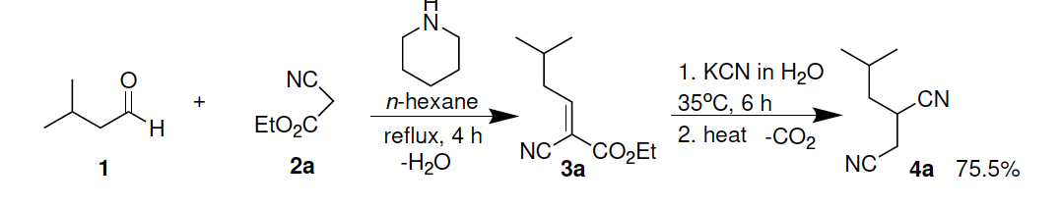
Scheme 1. Synthesis of racemic building block 4a for nitrilase catalysed kinetic resolution.

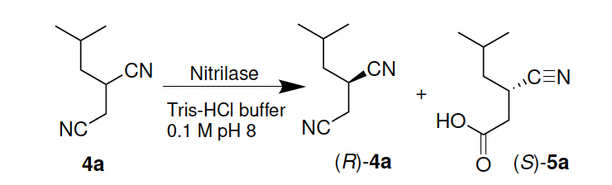

Scheme 2. Nitrilase catalysed kinetic resolution of 4a yielding (S)-5a (low yield)

Racemic 2-isobutylsuccinonitrile (4a) was synthesized in high yield and high purity by a Knoevenagel condensation of 3-methylbutanal (1) and ethyl 2-cyanoacetate (2a) followed by a conjugate addition of cyanide and decarboxylation. 4a was then subjected to kinetic resolution using 21 nitrilase variants provided by Syncozymes. The isolated yield of (S)-5a was low, which will be optimised.

Several of the nitrilases exhibited little or no measurable conversion in the kinetic resolution of 4a, which require further testing. Significant differences in activity and stereoselectivity were also observed in the different reactions.

The subsequent reduction of (S)-5a to pregabalin ((S)-6) by nitrile reductase ES-NRED-102 did not result in detectable product formation.

Sett inn et par referanser, så er det good tenker jeg.

