Predictive Control of Integrated Power Systems for Electrified Vehicles

Jing Sun
University of Michigan, Ann Arbor, U.S.A.

Integrated power systems (IPS) incorporate heterogeneous power sources, including energy storage systems, to achieve improved energy efficiency and reliability. They have been a critical enabling technology for vehicle electrification, as exemplified by their pervasive applications in hybrid electric vehicles and all electric ships. One special characteristic of IPS is the highly interactive and dynamic nature, due to tight physical couplings of the multiple components involved. To achieve high efficiency, one often needs to take advantage of knowing their operating profiles and pushing these systems to operate on or close to their admissible boundary, thereby calling for predictive control.
In this presentation, we will explore the special characteristics of the IPS and discuss the challenges and solutions of predictive control applied to this special class of systems. On the methodology side, we will present the integrated perturbation analysis and sequential quadratic programming (IPA-SQP) algorithm that was developed to deal with the fast and interactive dynamics of IPS. On the application side, we will cover several examples, including the IPS for all-electric ships and the integrated solid oxide fuel cell and gas turbine (SOFC/GT) system.

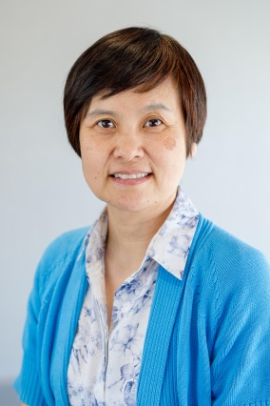
About the speaker: Prof. Jing Sun received her Ph. D degree from University of Southern California in 1989, and her master and bachelor degrees from the University of Science and Technology of China in 1984 and 1982. From 1989-1993, she was an assistant professor in the Electrical and Computer Engineering Department at Wayne State University. She joined Ford Research Laboratory in 1993, where she worked on advanced powertrain system controls. After spending almost 10 years in industry, she came back to academia in 2003 and joined the Naval Architecture and Marine Engineering Department at the University of Michigan where she is a professor now. She also has a joint appointment in the Electrical Engineering and Computer Science Department at the same university. She holds 38 US patents and has co-authored (with Petros Ioannou) a textbook on Robust Adaptive Control. She has published over 200 archived journal and conference papers. She is an IEEE Fellow and one of the three recipients of the 2003 IEEE Control System Technology Award.

