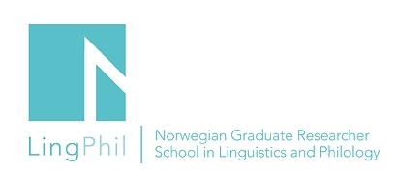

Announcement

Master class – Sigrunn Askland

PhD fellow Sigrunn Askland (UiA) will discuss her project with Professor Eva Thue Vold, the University of Oslo.

Title of the presentation: The status of grammar teaching in Norwegian secondary schools – A study of grammar teaching practices in the school subjects Norwegian, English and Spanish

Date: March 22, 2019
Time: 09.00 – 11.00
Venue: University of Agder, Room A 7001

You are all welcome to attend!
If you want to attend the event, please send an email to Gro-Renée Rambø,
gro-renee.rambo@uia.no.
LingPhil affiliated PhD fellows who plan to attend this event can apply for a travel grant.
They must send an application by using the application form on this link: http://www.ntnu.edu/lingphil/student-grants

