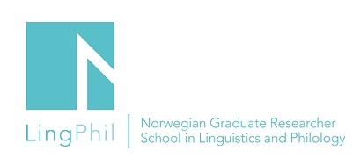

Announcement

Master class – Arild Høie Henriksen

PhD fellow Arild Høie Henriksen (UiA) will discuss his project with Professor Bjørn Lundquist, UiT The Arctic University of Norway.

Title of the presentation: The expletive passive in English and Norwegian

Date: March 28, 2019
Time: 09.15 – 11.30
Venue: University of Agder, Room B 2002

You are all welcome to attend!
If you want to attend the event, please send an email to Gro-Renée Rambø,
gro-renee.rambo@uia.no.
LingPhil affiliated PhD fellows who plan to attend this event can apply for a travel grant.
They must send an application by using the application form on this link: http://www.ntnu.edu/lingphil/student-grants

