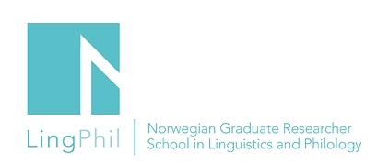

Announcement

Master class – Nazuki Kobayashi

Phd fellow Nazuki Kobayashi (UiB) will discuss her project with Professor Naoko Taguchi, Carnegie Mellon University, USA

Title of the presentation: Cross-cultural influence? The case of Norwegian students of Japanese with focus on the speech act of request

Date and time: February 25, 2019
Venue: University of Bergen, Room

You are all welcome to attend!
If you want to attend the event, please send an email to Harry Solvang Harry.Solvang@uib.no
LingPhil affiliated PhD fellows who plan to attend this event can apply for a travel grant.
They must send an application by using the application form on this link: http://www.ntnu.edu/lingphil/student-grants

